**Assignment-4**

**1.Write a program in C to read n number of values in an array and display it in reverse order.**

CODE

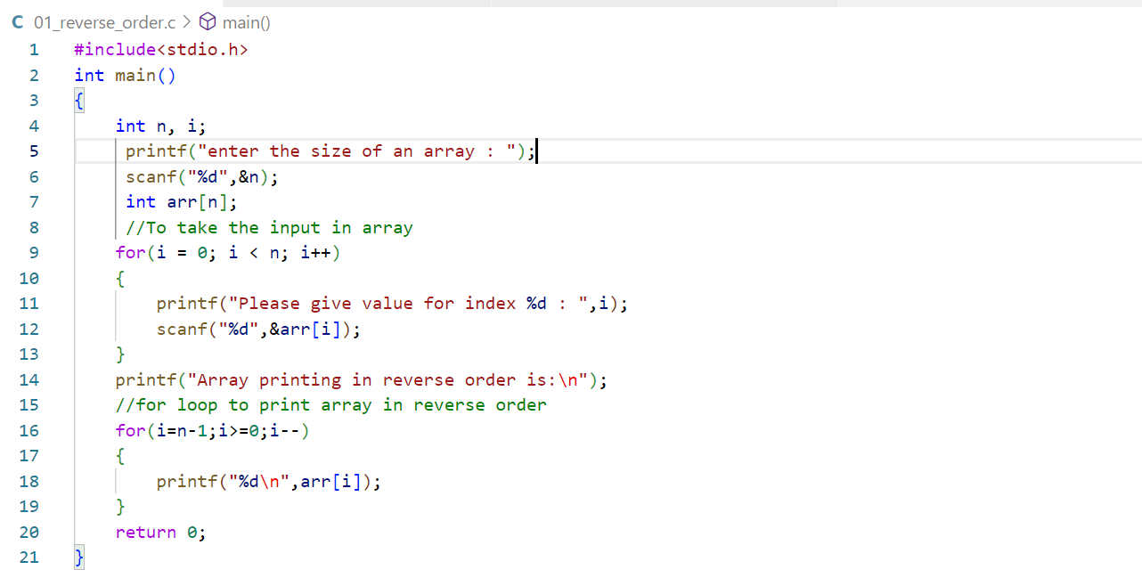

OUTPUT

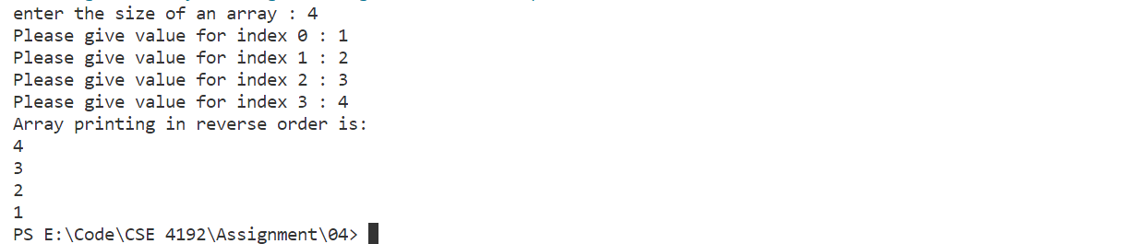

**2.Write a program in C to merge any two arrays entered by user at run-time.**

CODE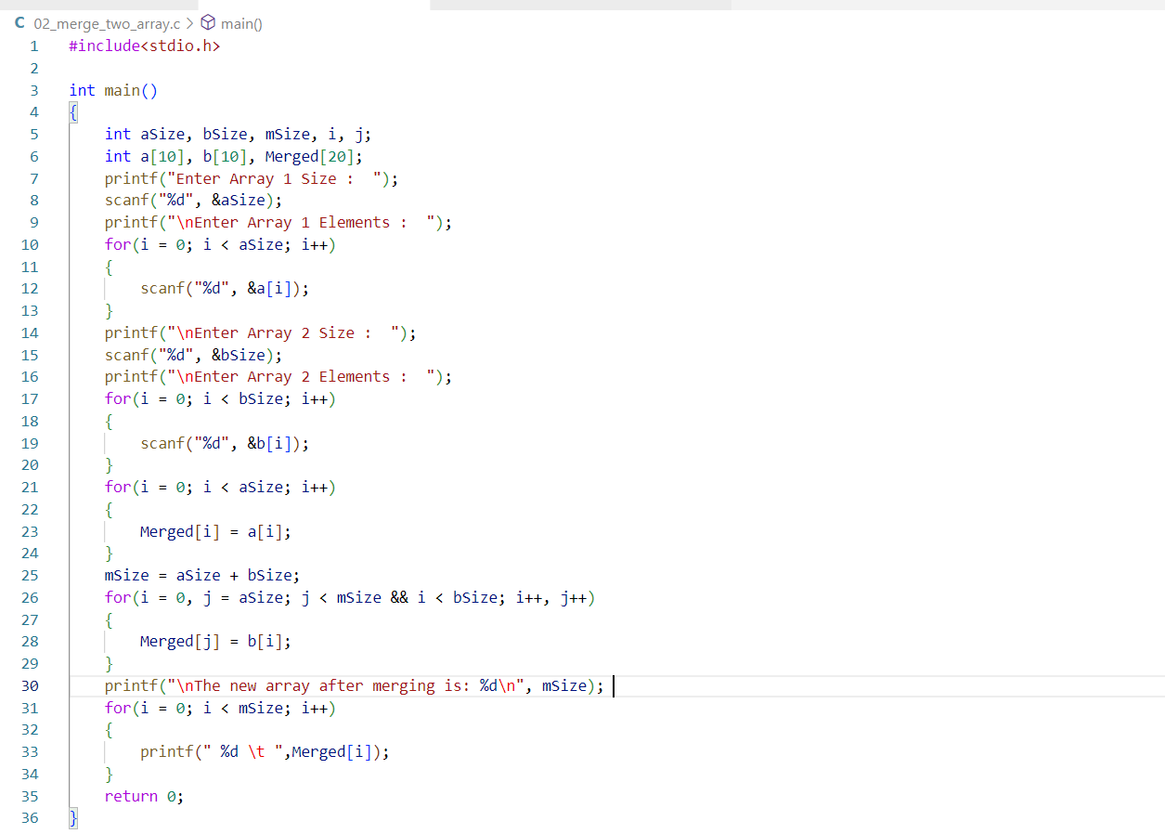

OUTPUT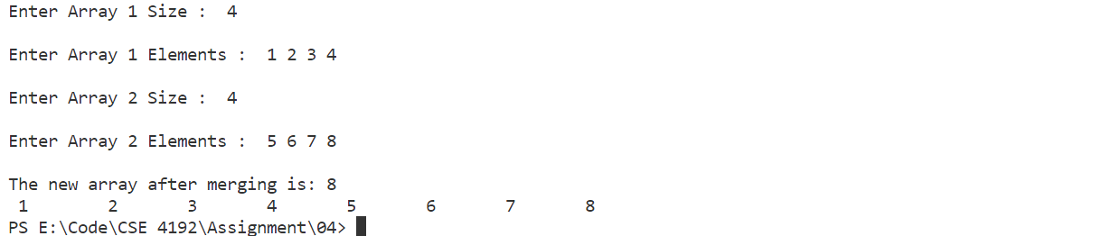

**3.Write a Program in C that asks from user to enter any 10 array elements, and then ask to enter a number to search from the given array and print its position.**

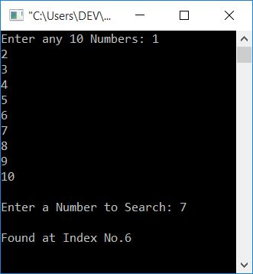

CODE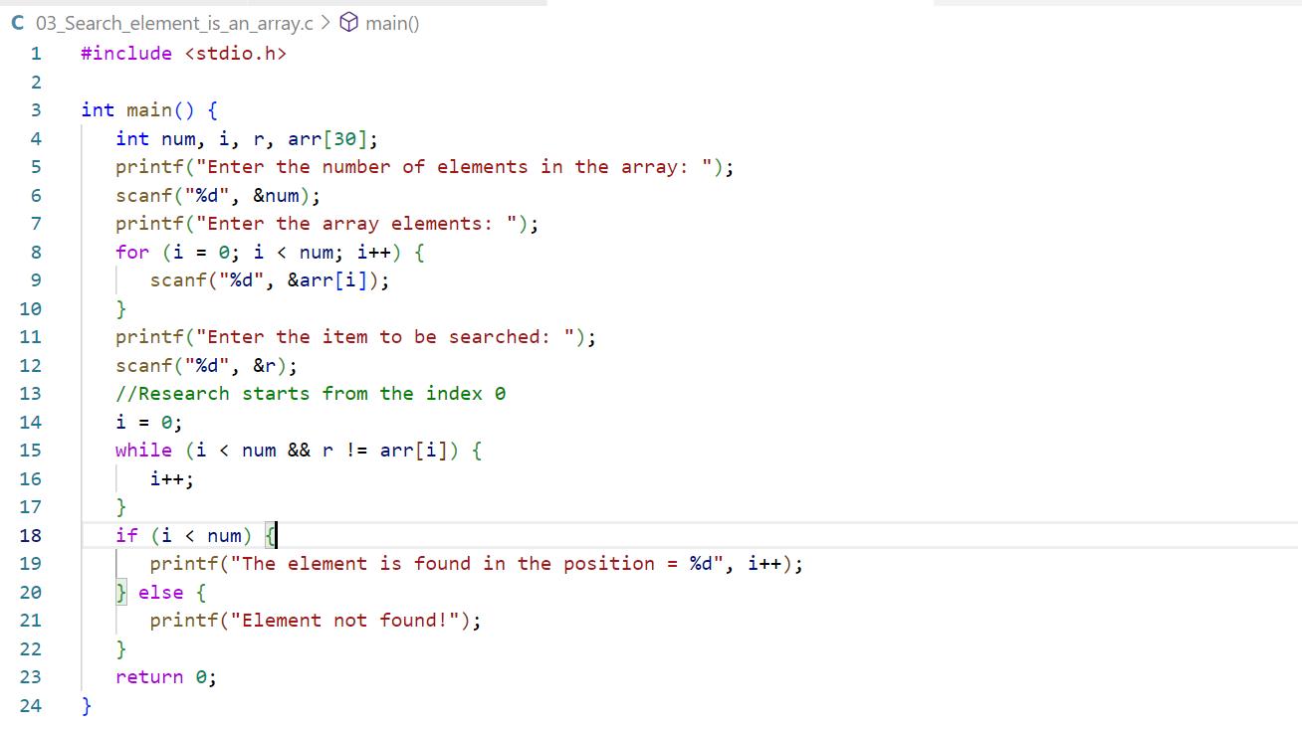

OUTPUT

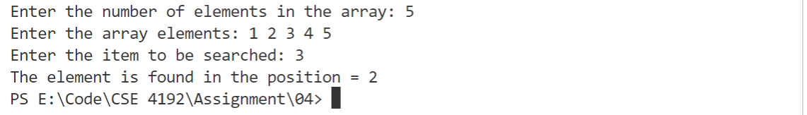

**Lab-4**

**1. Write a c program use do while loop to print a natural number.**

CODE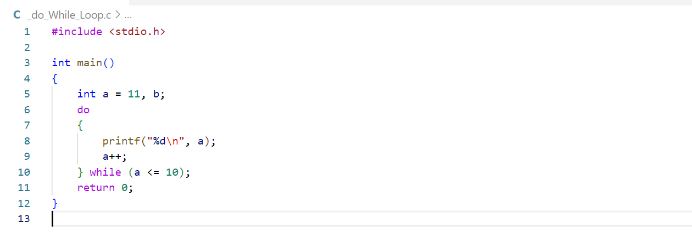

OUTPUT

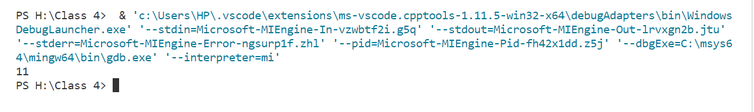

**2.Write a c program using while loop find positive and negative number.**

CODE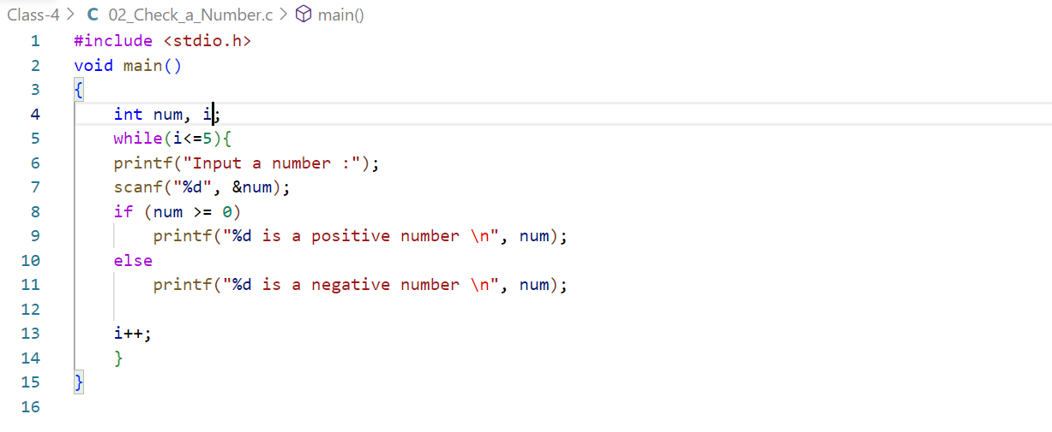

OUTPUT

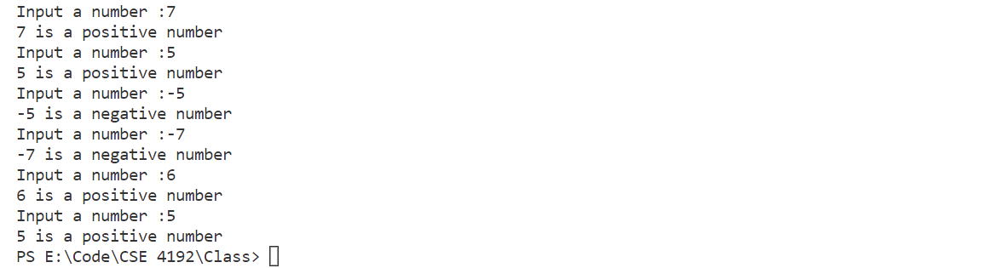

**3.Write a c program to find the sum of 10 input using array.**

CODE

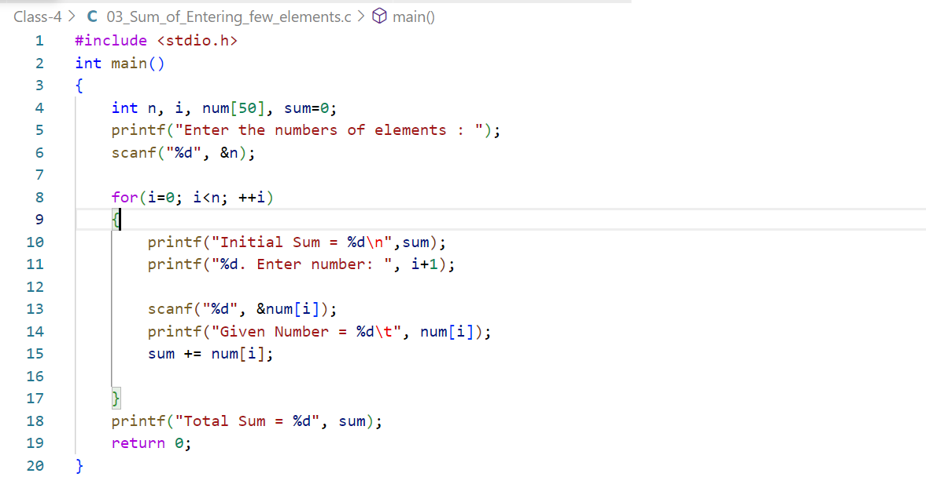

OUTPUT

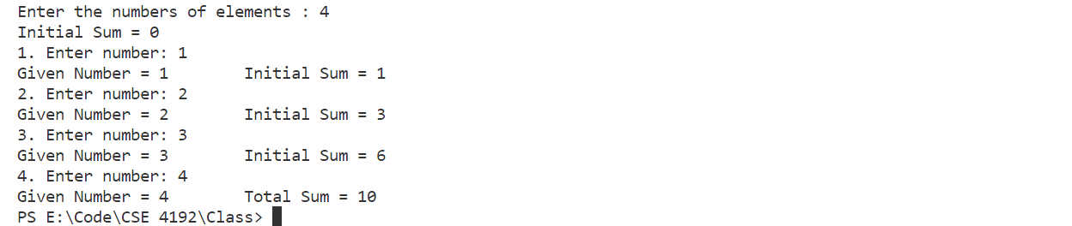

**4.Write a c program to find multiplication table.**

CODE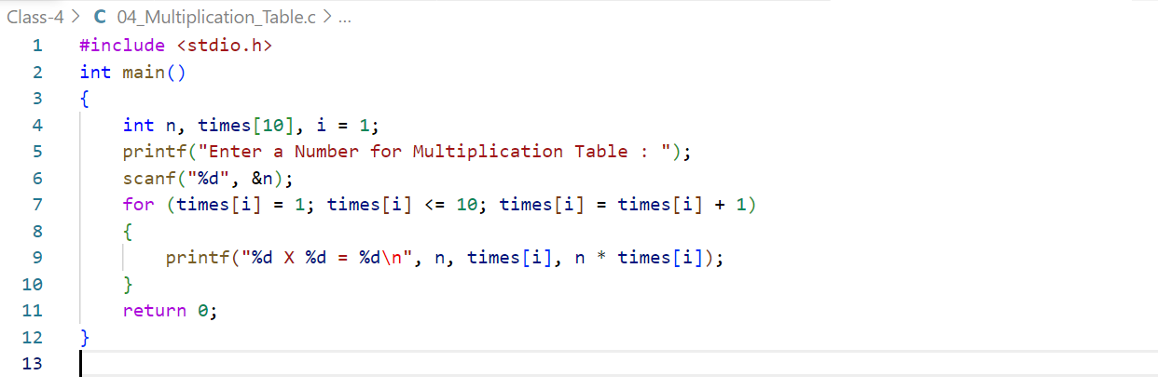

OUTPUT

